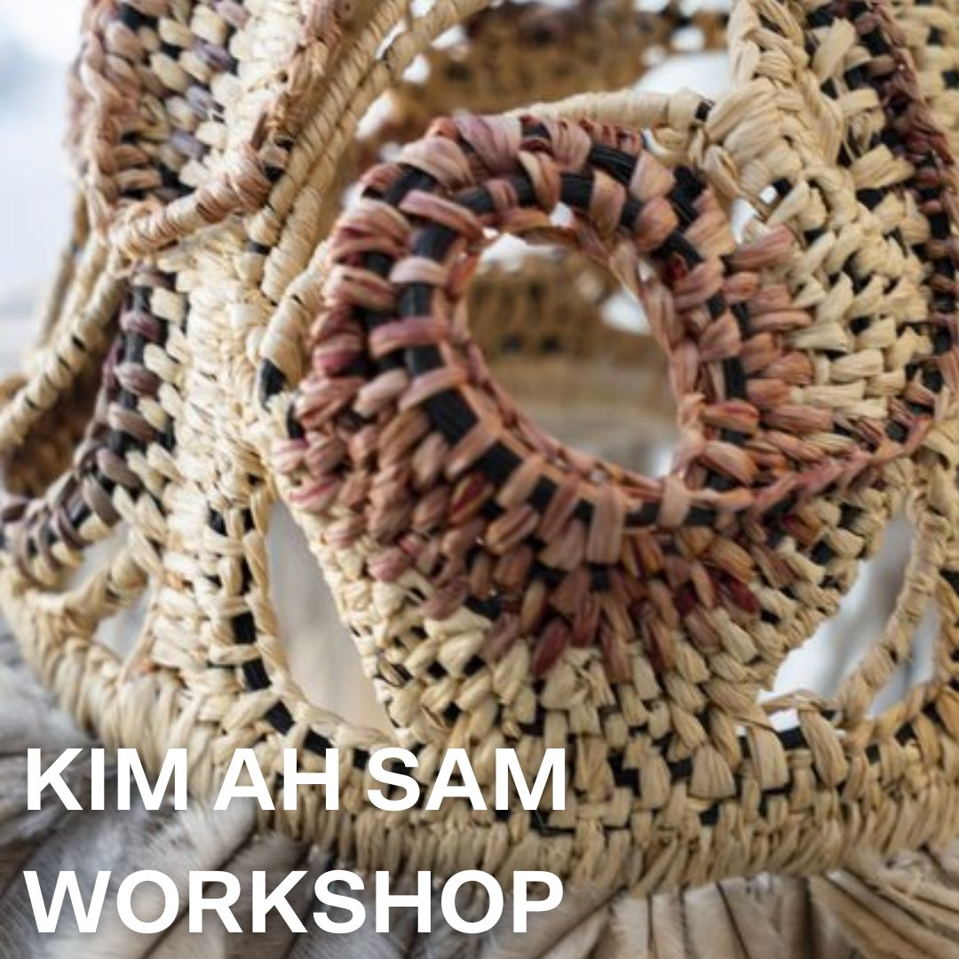

Open to students in years 10, 11 and 12 and UniSQ students

Learn a weaving practice that embodies storytelling and knowledge-sharing.

This workshop explores techniques of weaving, including woven sculptures, made from repurposed twine, raffia, bamboo, and emu feathers. The unique weaving technique evokes at once a sensibility to traditional Aboriginal basket weaving practices while also expressing a free formed and experimental ‘searching’ as the artist journeys through each vessel with woven lines bound only by the bamboo structures beneath.

Ah Sam teaches weaving as a therapeutic practice towards a process of cultural healing and a way to address feelings of disconnection and reconnection with her Country.
APPLICATION FORM
Class: | Weaving (Student to supply materials)
Date: | 26-30 June 2023
Tutor: | Kim Ah Sam
Time: | 9am – 4pm
Room: | Q150
Application Due: | 8 May 2023
Inclusions: | Cost of course ($400 excluding materials cost)
Materials costs: | Approximately $45

Please complete
Student Name | Click or tap here to enter text.
Address: | Click or tap here to enter text.
Phone: | Click or tap here to enter text.
Email: | Click or tap here to enter text.
Name of School: | Click or tap here to enter text.
Year level | Click or tap here to enter text.
Gender | Click or tap here to enter text.
Do you identify as Aboriginal or Torres Strait Islander? | Yes ☐ No ☐
Why would you like to attend? | Click or tap here to enter text.
What is your current career trajectory? | Click or tap here to enter text.
Would you be able to attend if you do not receive this scholarship? | Yes ☐ No ☐

Conditions
- Applications must be received by the closing date of 8 May, 2023
- Bursary recipients may be asked to participate in assisting to promote UniSQ as required.
- Bursaries are not transferable to other students in any circumstances.
- Bursaries are not transferable to another event.
- UniSQ reserves the right to alter these conditions based upon exceptional circumstances.

Selection Criteria
Applicants:
- must meet the eligibility requirements outlined in this document.
- must answer the questions outlined above
- may demonstrate financial hardship; students experiencing financial difficulty will have higher preference.

STUDENTS UNDER 18 YRS

Parents/Guardians of Junior Students (under 18 years) must advise the Administration if the Applicant is subject to any form of chronic illness that is likely to require medical attention during the period of the Winter School.

STATEMENT BY APPLICANT/PARENT/GUARDIAN

I agree to co-operate with the staff and students and abide by the Management’s decisions. Should medical or hospital expenses be incurred on my behalf during the School, I agree to accept and pay all costs, and to exonerate UniSQ/McGregor Winter School from responsibility in this regard.

Signature of Parent or Guardian (if applicant under 18 years)

Signed – Parent / Guardian

Name: Click or tap here to enter text.

Phone: Click or tap here to enter text.

Email: Click or tap here to enter text.

*We will advise all applicants of the outcome of their application by Friday 26 May 2023 and we will acknowledge your application upon receipt by email. Please provide an email you access regularly.

For assistance, please contact Ali Lawson:
McGregorschools@usq.edu.au
07 4631 1501

