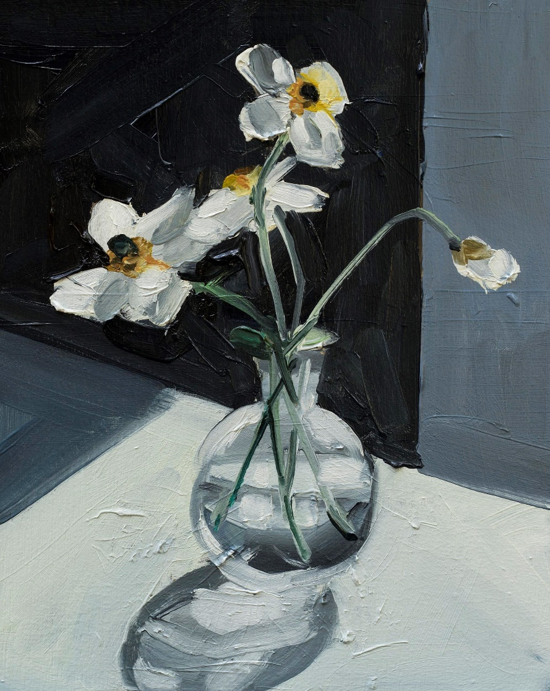

Open to students in years 10, 11 and 12 and UniSQ students

This painting workshop will explore the fun free flowing technique of Alla Prima, a ‘wet on wet’ oil painting technique. Participants will be guided in a relaxed environment to explore mark making and brush techniques and enjoy the instant gratification of finished works created in a single sitting.
This is a fun, hands-on introduction to oil painting focusing on the no fuss approach that the Alla Prima technique lends itself to. Artist Lauren Jones will guide you through the basics of using oils and share her impressionistic, free flowing and fast approach to creating vibrant and dynamic still life paintings. Be prepared to get messy and loosen up with some gestural painting exercises and explore the genre of still life through new arrangements and themes each day. Participants will learn how to represent colour, light, tone and form to create atmosphere in finished artworks. Discover new fresh ways of seeing compositions and still life scenes within a relaxed environment. Over this five-day workshop and participants will take home many finished artworks.

APPLICATION FORM
Class: | Alla Prima - Still Life (Student to supply materials)
Date: | 26-30 June 2023
Tutor: | Lauren Jones
Time: | 9am – 4.30pm
Room: | Q166
Application Due: | 8 May 2023
Inclusions: | Cost of course ($400 excluding materials cost)
Materials costs: | Approximately $

Please complete
Student Name | Click or tap here to enter text.
Address: | Click or tap here to enter text.
Phone: | Click or tap here to enter text.
Email: | Click or tap here to enter text.
Name of School: | Click or tap here to enter text.
Year level | Click or tap here to enter text.
Gender | Click or tap here to enter text.
Do you identify as Aboriginal or Torres Strait Islander? | Yes ☐ No ☐
Why would you like to attend? | Click or tap here to enter text.
What is your current career trajectory? | Click or tap here to enter text.
Would you be able to attend if you do not receive this scholarship? | Yes ☐ No ☐

Conditions
- Applications must be received by the closing date of 8 May,2023
- Bursary recipients may be asked to participate in assisting to promote UniSQ as required.
- Bursaries are not transferable to other students in any circumstances.
- Bursaries are not transferable to another event.
- UniSQ reserves the right to alter these conditions based upon exceptional circumstances.

Selection Criteria
Applicants:
- must meet the eligibility requirements outlined in this document.
- must answer the questions outlined above
- may demonstrate financial hardship; students experiencing financial difficulty will have higher preference.

STUDENTS UNDER 18 YRS

Parents/Guardians of Junior Students (under 18 years) must advise the Administration if the Applicant is subject to any form of chronic illness that is likely to require medical attention during the period of the Winter School.

STATEMENT BY APPLICANT/PARENT/GUARDIAN

I agree to co-operate with the staff and students and abide by the Management’s decisions. Should medical or hospital expenses be incurred on my behalf during the School, I agree to accept and pay all costs, and to exonerate UniSQ/McGregor Winter School from responsibility in this regard.

Signature of Parent or Guardian (if applicant under 18 years)

Signed – Parent / Guardian

Name: Click or tap here to enter text.

Phone: Click or tap here to enter text.

Email: Click or tap here to enter text.

*We will advise all applicants of the outcome of their application by Friday 26 May 2023 and we will acknowledge your application upon receipt by email. Please provide an email you access regularly.

For assistance, please contact Ali Lawson:
McGregorschools@usq.edu.au
07 4631 1501

